**EX.NO:3 DATE: 30.01.2025**

**IMAGE TRANSFORMATION**

**Aim:**

To implement various geometric transformations on an image, including Translation, Rotation, Scaling, Shearing, and Reflection, using Python.

**Algorithm:**

1. Read the input image using OpenCV or PIL.
2. Apply the following transformations:
   * **Translation**: Shift the image by a specified amount in x and y directions.
   * **Rotation**: Rotate the image by a specified angle.
   * **Scaling**: Resize the image using interpolation.
   * **Shearing**: Apply shearing transformation along x and y axes.
   * **Reflection**: Generate mirrored images by flipping along horizontal, vertical, and diagonal axes.
3. Display the original and transformed images using Matplotlib.
4. Save the transformed images if necessary.

**Code**:

import cv2  
import numpy as np  
import matplotlib.pyplot as plt  
import math  
from PIL import Image

img = cv2.imread('A.png',1)  
img = cv2.cvtColor(img, cv2.COLOR_BGR2RGB)

# Translation

height, width = img.shape[:2]

tx, ty = 80, 80

y_indices, x_indices = np.indices((height, width))

ones = np.ones_like(x_indices.flatten())  
coords = np.stack([x_indices.flatten(), y_indices.flatten(), ones])  
  
translation_matrix = np.array([  
 [1, 0, tx],  
 [0, 1, ty],  
 [0, 0, 1]  
])  
translated_coords = translation_matrix @ coords  
translated_x, translated_y = translated_coords[0].astype(int), translated_coords[1].astype(int)  
translated_image = np.zeros((height, width, 3), dtype=np.uint8)

mask = (  
 (translated_y >= 0) & (translated_y < height) &  
 (translated_x >= 0) & (translated_x < width)  
)  
translated_image[translated_y[mask], translated_x[mask]] = img[y_indices.flatten()[mask], x_indices.flatten()[mask]]  
  
output_image = Image.fromarray(translated_image)  
plt.figure(figsize=(12, 10))  
plt.subplot(1, 2, 1)  
plt.imshow(img)  
plt.title('Original Image')  
plt.axis('Off')  
plt.subplot(1, 2, 2)  
plt.imshow(output_image)  
plt.title('Translated Image')  
plt.axis('Off')  
plt.show()

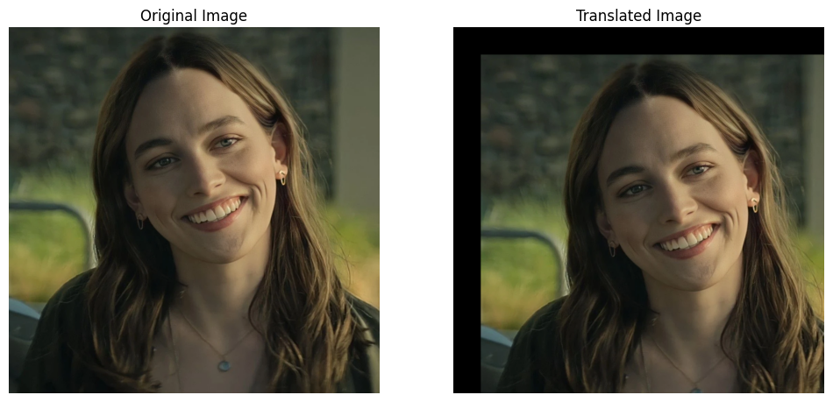

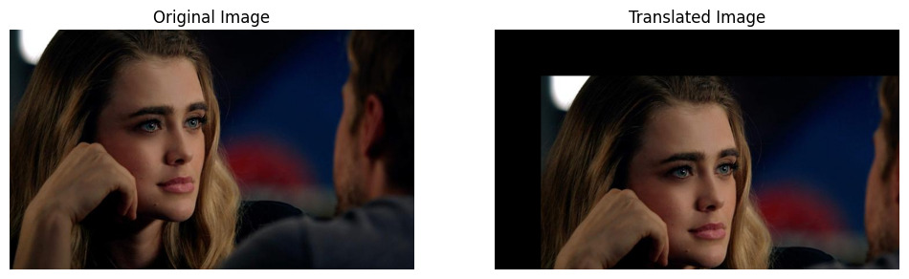

# Rotation

height, width = img.shape[:2]

rotation_amount_degree = 45  
rotation_amount_rad = np.deg2rad(rotation_amount_degree)

new_height = int(np.ceil(np.sqrt(height**2 + width**2)))  
new_width = new_height  
  
y_indices, x_indices = np.indices((new_height, new_width))

new_center = (new_width // 2, new_height // 2)  
  
x_indices_centered = x_indices - new_center[0]  
y_indices_centered = y_indices - new_center[1]  
  
ones = np.ones_like(x_indices_centered)  
coords = np.stack([x_indices_centered.flatten(), y_indices_centered.flatten(), ones.flatten()])  
  
cos_a = np.cos(rotation_amount_rad)  
sin_a = np.sin(rotation_amount_rad)  
rotation_matrix = np.array([  
 [cos_a, -sin_a, 0],  
 [sin_a, cos_a, 0],  
 [0, 0, 1]  
])  
  
rotated_coords = rotation_matrix @ coords  
rotated_x, rotated_y = rotated_coords[0] + width // 2, rotated_coords[1] + height // 2  
  
rotated_image = np.zeros((new_height, new_width, 3), dtype=np.uint8)  
  
mask = (  
 (rotated_y >= 0) & (rotated_y < height) &  
 (rotated_x >= 0) & (rotated_x < width)  
)  
rotated_image[y_indices.flatten()[mask], x_indices.flatten()[mask]] = img[rotated_y[mask].astype(int), rotated_x[mask].astype(int)]  
  
output_image = Image.fromarray(rotated_image)  
plt.figure(figsize=(12, 10))  
plt.subplot(1, 2, 1)  
plt.imshow(img)  
plt.title('Original Image')  
plt.axis('Off')  
plt.subplot(1, 2, 2)  
plt.imshow(output_image)  
plt.title('Rotated Image')  
plt.axis('Off')  
plt.show()

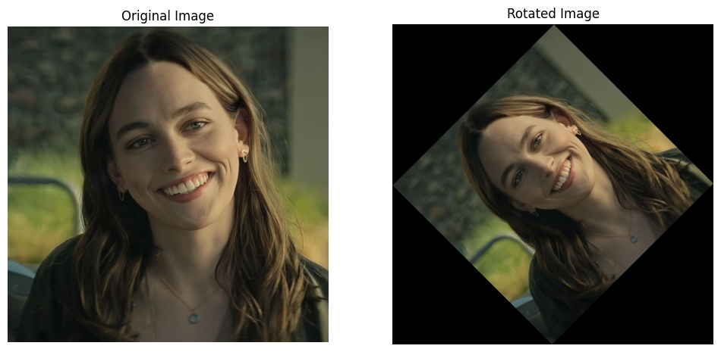

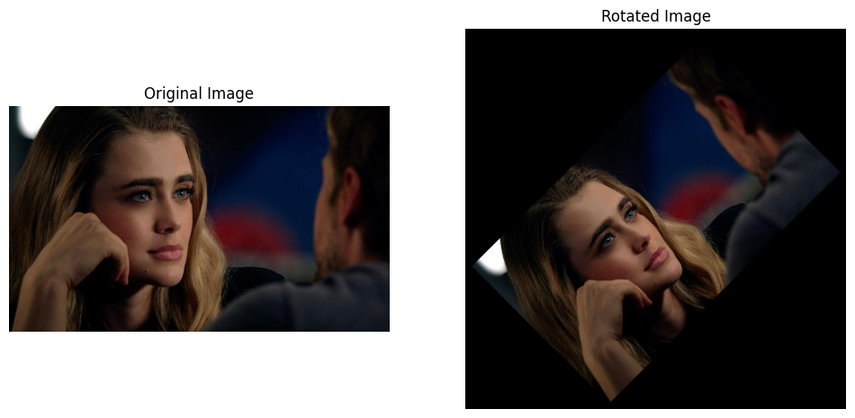

# Scaling

image = cv2.imread("A.png")  
rows, cols, channels = image.shape  
  
scale_x, scale_y = 2.0, 2.0  
  
new_width = int(cols * scale_x)  
new_height = int(rows * scale_y)  
  
x_new = np.linspace(0, cols - 1, new_width)  
y_new = np.linspace(0, rows - 1, new_height)  
  
x_old, y_old = np.meshgrid(np.floor(x_new / scale_x).astype(int),  
 np.floor(y_new / scale_y).astype(int))  
  
x_old = np.clip(x_old, 0, cols - 1)  
y_old = np.clip(y_old, 0, rows - 1)  
  
scaled_image = image[y_old, x_old]  
  
plt.figure(figsize=(12, 10))  
plt.subplot(1, 2, 1)  
plt.imshow(img)  
plt.title('Original Image')  
plt.axis('Off')  
plt.subplot(1, 2, 2)  
plt.imshow(cv2.cvtColor(scaled_image, cv2.COLOR_BGR2RGB))  
plt.title("Scaled Image (2x)")  
plt.axis('Off')  
plt.show()

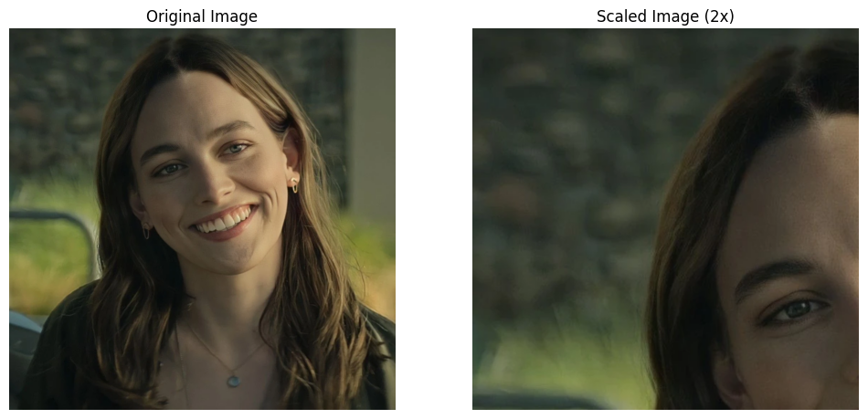

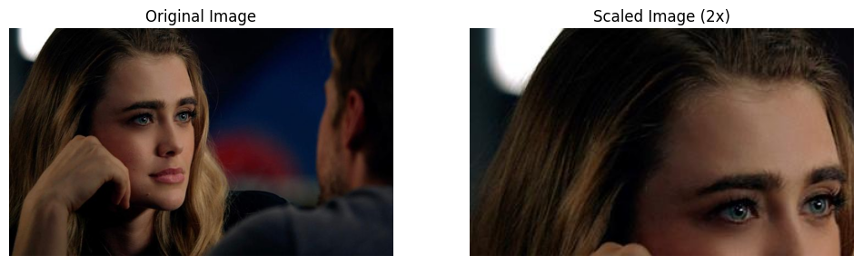

# Shearing

def shear_image(image_path, shear_x=0, shear_y=0):  
 image = Image.open(image_path)  
 original_width, original_height = image.size  
 img_array = np.array(image)  
   
 new_width = original_width + int(shear_x * original_height)  
 new_height = original_height + int(shear_y * original_width)  
 sheared_image_array = np.zeros((new_height, new_width, img_array.shape[2]), dtype=np.uint8)  
   
 for i in range(new_height):  
 for j in range(new_width):  
 orig_x = int(j - shear_x * i)  
 orig_y = int(i - shear_y * j)  
   
 if 0 <= orig_x < original_width and 0 <= orig_y < original_height:  
 sheared_image_array[i, j] = img_array[orig_y, orig_x]  
   
 sheared_image = Image.fromarray(sheared_image_array)  
 return sheared_image  
  
sheared_image = shear_image("A.png", shear_x=0.5, shear_y=0.1)   
  
plt.figure(figsize=(12, 10))  
plt.subplot(1, 2, 1)  
plt.imshow(img)  
plt.title('Original Image')  
plt.axis('Off')  
plt.subplot(1, 2, 2)  
plt.imshow(sheared_image)  
plt.title('Sheared Image')  
plt.axis('Off')  
plt.show()

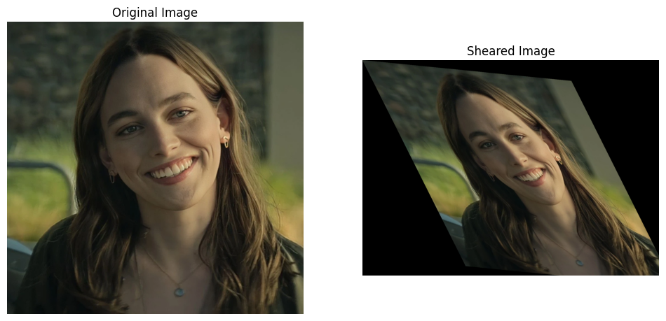

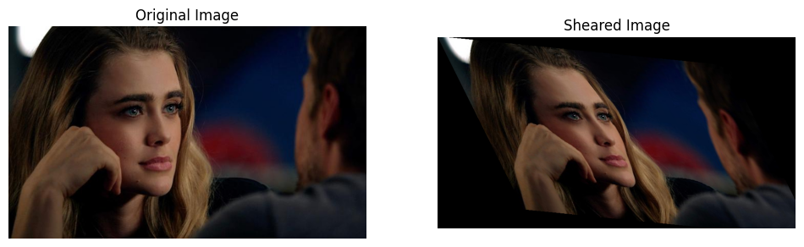

# Reflection

def apply_inversions(image_path):  
 image = Image.open(image_path)  
 img_array = np.array(image)  
   
 horizontal_inversion = np.flip(img_array, axis=1)  
  
 vertical_inversion = np.flip(img_array, axis=0)  
  
 rotated_180 = np.flip(img_array, axis=(0, 1))  
  
 diagonal_inversion = np.transpose(img_array, axes=(1, 0, 2))

return img_array, horizontal_inversion, vertical_inversion, rotated_180, diagonal_inversion  
  
image_path = "A.png"  
original, horizontal, vertical, rotated_180, diagonal = apply_inversions(image_path)  
  
fig, axes = plt.subplots(1, 5, figsize=(20, 10))  
  
axes[0].imshow(original)  
axes[0].set_title("Original Image")  
axes[0].axis('off')   
axes[1].imshow(horizontal)  
axes[1].set_title("Horizontal Inversion")  
axes[1].axis('off')  
  
axes[2].imshow(vertical)  
axes[2].set_title("Vertical Inversion")  
axes[2].axis('off')  
  
axes[3].imshow(rotated_180)  
axes[3].set_title("180-degree Rotation")  
axes[3].axis('off')  
  
axes[4].imshow(diagonal)  
axes[4].set_title("Diagonal Inversion")  
axes[4].axis('off')  
  
plt.tight_layout()  
plt.show()

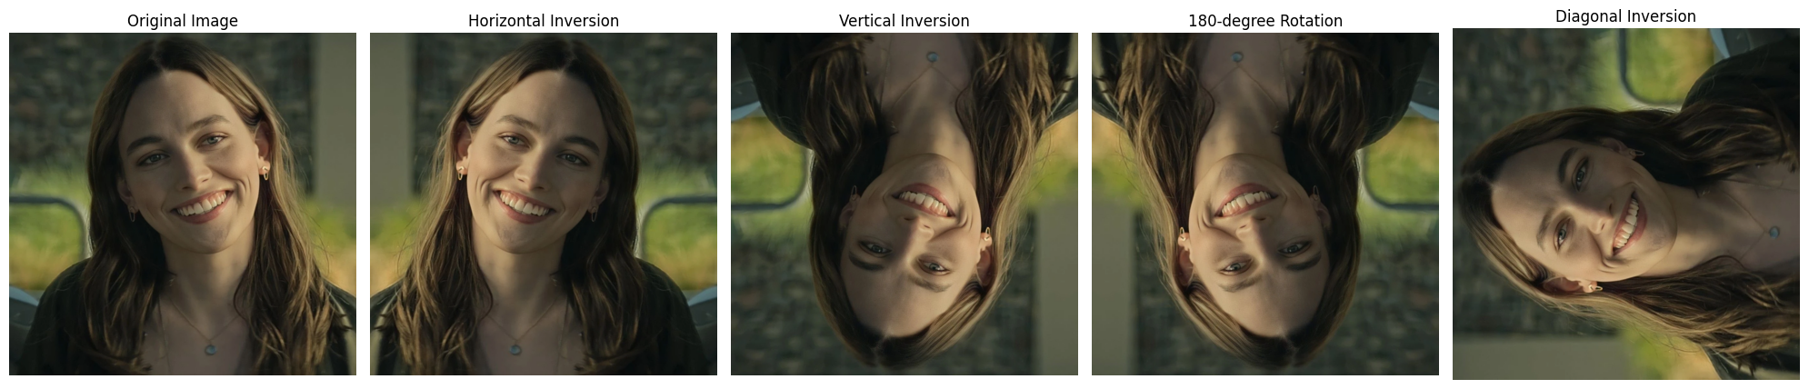

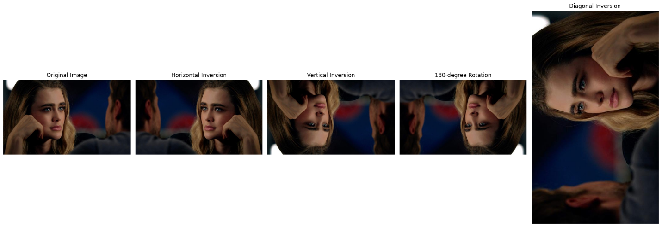

**Inference**

1. The geometric transformations were successfully applied to the input image.
2. The transformed images demonstrate the correct implementation of translation, rotation, scaling, shearing, and reflection.
3. The output visualizations confirm the expected results of each transformation.
4. This implementation can be extended for more complex transformations in image processing tasks.

**Result:**

The transformations were successfully applied, and the output images accurately reflect translation, rotation, scaling, shearing, and reflection.